**EE308FZ Software Engineering**

**Group Project**

**Group 5: IoT Garbage Manager**



**Software Requirements Specification**

**Group Member**

Hanlin Cai (Leader), Jiaqi Hu, Zheng Li, Shuying Liu, Zhijun Zhao

Yinheng Lin,Youlin Feng, Jingjie Yu, Shipei Zhang

**CONTENTS**

**1. Project Logo** 3

**2. Background** 3

2.1 Purpose 3

2.2 Background 3

2.3 Intended Readers and Reading Suggestions 4

**3. User Portrait** 4

**4. Requirement analysis** 5

4.1 Need 5

4.2 Approach 5

4.3 Benefits 5

4.4 Competitors 6

4.5 Delivery 6

**5. Competitive Product Analysis** 6

5.1 Strength 6

5.2 Weakness 7

5.3 Opportunity 7

5.4 Threaten 7

**6. Mind Mapping** 7

**7. Class Diagram** 8

7.1 Data Collection 8

7.2 User Management 9

3.2.3 Data Processing 10

3.2.4 Visualization 12

**8. Interface Prototype** 13

8.1 Login screen 13

8.2 User Interface 13

8.3 Administrator Interface 15

**9. Function Description** 18

9.1 User Module 18

9.2 Administrator Module 19

9.3 Notification Module 19

9.4 Garbage Management Module 19

9.5 Environmental Protection Related Articles Module 20

9.6 Comment Module 20

**10. Acceptance Verification Criteria** 21

10.1 Layout Test 21

10.2 Data Visualization 21

10.3 User Interaction 22

**11. Acknowledgements** 23

# **Project Logo**

The logo of the project is the first letter of MIEC (Maynooth International Engineering College), witnessing the process of increasing strength of the whole team and indicating the desire to create the best project.



Fig. 1 Team Logo (MIEC)

# **Background**

## 2.1 Purpose

This opening report is written to clarify the detailed requirements of this project for users to confirm the functionality and performance of the project. It also forms a consistent understanding and confirmation with users as a basis for further detailed design of the software. This document is for the IoT Garbage Manager team to conduct reference with teachers and teaching assistants.

## 2.2 Background

Nowadays, in the construction of ecological civilization in cities, municipal garbage management is a key point that cannot be ignored. For a long time, China has not paid enough attention to solid waste recycling and disposal issues and has not invested enough. Traditional garbage recycling companies often rely on a large number of manual labors, as well as extensive garbage bin deployment to improve the rate of waste disposal which are inefficient at all. So, public's garbage drop-off experience is poor, and the garbage recycling companies are facing heavy workload and finical budget.

This project is dedicated to establishing a new intelligent IoT garbage management system that can be organically integrated with the sustainable development needs of the economy, society and municipal waste disposal. We apply the IoT system to the construction of smart cities to help solve a series of difficulties in municipal waste recycling today.

## 2.3 Intended Readers and Reading Suggestions

Table 1 Intended Readers and Reading Suggestions

|  |  |
| --- | --- |
| **Intended Readers** | **Reading Suggestions** |
| Project Managers | After reading this document, the project manager can understand the expected functions of the product, analyze the user requirements of the product, and design and manage the project systematically based on the contents of this document. |
| Developers | After reading this document, the developers can analyze the requirements of the project and design the architecture of the front-end and back-end systems of the project. Finally, according to the requirements and design, implement the project functions and write the user manual. |
| Marketers | Understand the background and function of the project and design the corresponding marketing strategy. |
| Testers | Understand the expected functionality of the project based on the documentation and design the test cases accordingly. |
| Users | Understand the functionality of the project and negotiate with developers on changes in requirements and the expected outcome of the project. |

# **User Portrait**

Table 2 User Portrait

|  |  |  |
| --- | --- | --- |
| **User Category** | | **Demand Characteristics** |
| Citizens | | Learn the rules of waste separation  Checking the amount of separated garbage cans left  Receive waste separation news |
| City Managers | Management team | Coordinate management |
| Publicity Team | Promote garbage classification tweets |
| Matching group | Notify garbage disposal personnel through the system  Telephone contact in special cases |
| Garbage disposal staff | | Targeted garbage collection and disposal after receiving notification |

# **Requirement analysis**

## 4.1 Need

With municipalities requiring waste separation, there is a lack of understanding and enforcement of waste separation, as well as difficulties for municipal administrators to know in real time the status of the separated bins placed, and to promote it more accurately and effectively. When faced with a large amount of waste that needs to be recycled, the traditional methods are still used, i.e., relying on a large amount of manual labor and extensive deployment of garbage bins to increase the waste disposal rate. These traditional methods are inefficient, the public's garbage drop-off experience is poor, and the garbage collection companies are costly and business heavy.

## 4.2 Approach

Our garbage management system is based on NODUMCU, GSM chip, mainly through ultrasonic and temperature sensing technology as a monitoring means to analyze the status of garbage cans, and then use the existing machine learning model to pre-process the garbage information for classification, so as to obtain the required information more efficiently, and then upload the effective data to AliCloud IoT development platform through NODEMCU module for visualization, and finally dumped to the Web platform, thus allowing citizen users, government managers and government enterprise staff to easily and efficiently access the required information. At the same time, we use the simulated degradation algorithm for waste recycling route planning, and the route information will be sent to the staff via GSM module to remind SMS, so as to reach the efficient, convenient and user-friendly "sampling, computing, interconnection, processing" mechanism, which helps to solve the key, painful and difficult problems in municipal waste recycling nowadays.

## 4.3 Benefits

(i) Citizen Users

Provide the public with knowledge about waste separation and promotional tweets and provide the waste drop-off location and current overflow level, so that the public can effectively separate waste.

(ii) Government Administrators

Provide government administrators with comprehensive and multi-dimensional information on the status of garbage cans, and with the help of algorithms, provide them with early warning alerts and assist in connecting with garbage disposal staff to arrange the best scheduling routes.

(iii) Garbage Disposal Staff

We provide accurate and easy-to-read disposal instructions and a variety of simple directions for garbage disposal staff and arrange them to receive messages for garbage collection in a timely manner, taking into account the actual situation and humanistic concerns.

## 4.4 Competitors

Most competing software on the market now has a single function or is too difficult to use and cannot take into account the professionalism and universality of garbage disposal.

## 4.5 Delivery

The pilot was launched on campus to expand the student user base by interfacing with the school's logistics management, registering managers and garbage disposal staff, and promoting through campus self-publishing. After the pilot run, actively collect feedback from staff members on usage, and user experience feedback, and make certain improvements.

We put the pilot in the community, docked with the community's logistics management department, entered this garbage management system through the jump of the community app for the corresponding operation, and promoted through the community public number tweets and the community app's message push, etc. to expand the community user group. After the pilot run, we will actively collect feedback from staff and users and make some improvements.

Under the normal promotion of the above pilot and more practical applications of the pilot, we will try to publicize and promote with the municipal management in the hope of conducting pilot and cooperation to expand more citizen users.

# **Competitive Product Analysis**

We mainly focus on the competitor analysis of **Willas Smart garbage Management System** and **Zhuocan Smart Sanitation System**.

## 5.1 Strength

Willas has very perfect functions from the management point of view, realizing business collaboration, management visualization, supervision refinement, command and dispatch efficiency, fast incident processing and operation assessment standardization.

Zhuocan has very complete functions from the perspective of waste disposal enterprises, realizing the functions related to waste classification such as intelligent domestic waste collection and transportation, waste transfer station supervision and waste disposal site supervision for sanitation enterprises.

## 5.2 Weakness

There is no good connection with the citizens who carry out waste separation, i.e., the problem of inefficient waste separation and disposal by the citizens cannot be solved at the source.

## 5.3 Opportunity

Our IoT garbage management system comprehensively considers government management groups, citizen user groups and related staff, integrating management applications and implementing waste separation management to citizens and related staff.

## 5.4 Threaten

If our management system considers more user groups and functions, it may not be as accurate as Willas in facing the challenge of a single group of municipal management users, and not as suitable as Zhuocan in facing the challenge of a single user of waste disposal personnel.

# **MindMind Mapping**

Fig. 2 Mind Map

# **7. Class Diagram**

## 7.1 Data Collection

Persons in charge: Jiaqi Hu, Zheng Li, Hanlin Cai

Description: The data collection part is mainly done by the back-end code of the hardware device installed on the bin, which monitors the capacity in the bin and saves the correct data in the database.

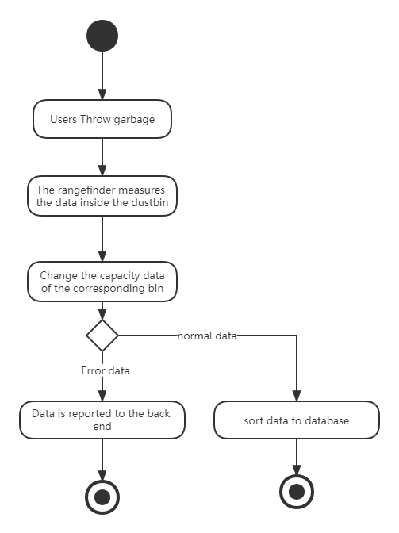

Fig. 3 State char Diagram

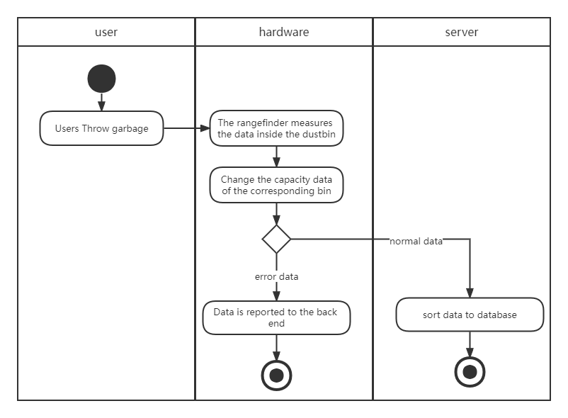

Fig. 4 Swim Lane Diagram

## 7.2 User Management

Persons in charge: Zheng Li, Jingjie Yu, Hanlin Cai

Description: The user management part realizes different interfaces and corresponding functions for different groups of people, i.e. normal users and administrators, through different login methods.

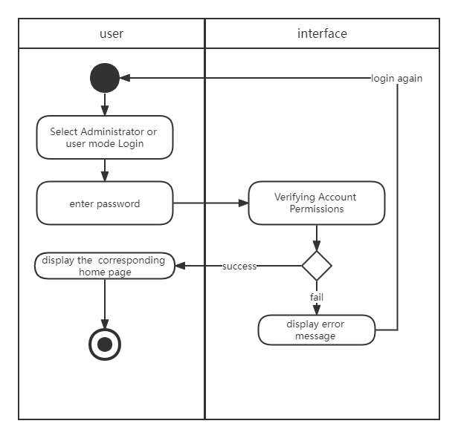

Fig. 5 Activity Diagram

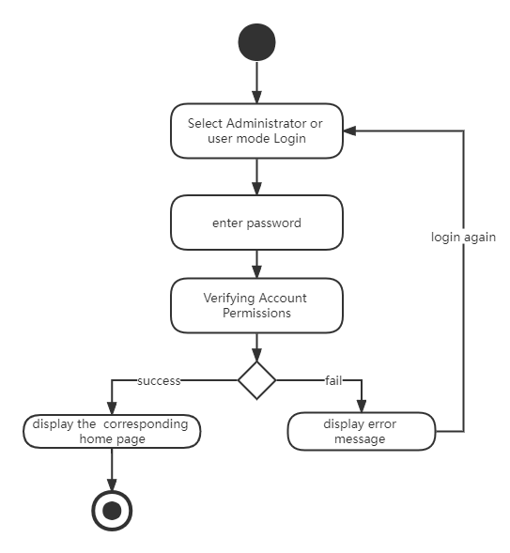

Fig. 6 State char Diagram

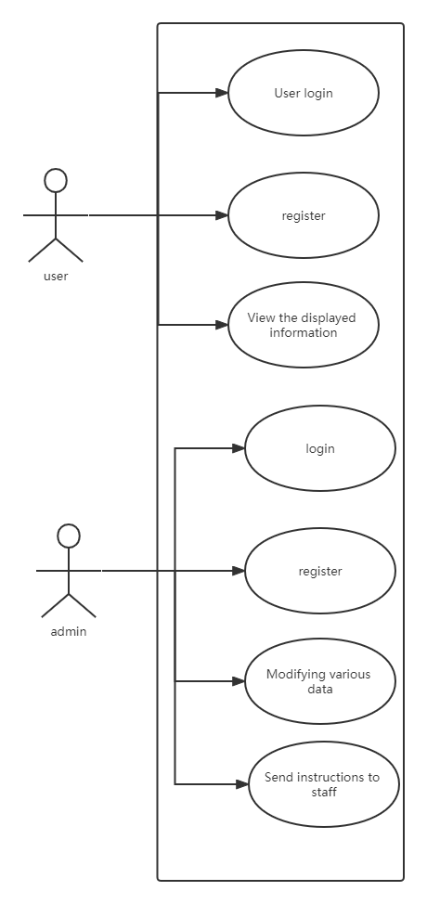

Fig. 7 Use Case Diagram

## 3.2.3 Data Processing

Persons in charge: Jiaqi Hu, Shipei Zhang, Shuying Liu

**Description:**

Build and debug JavaWeb, database and related server parts of the garbage monitoring system.

Problems faced by this part: Need to consider the architecture of the database and server side comprehensively, and how to cooperate with the front end to effectively display the data.

**Problems faced by this part:**

Need to consider the architecture of the database and server side comprehensively, and how to cooperate with the front end to effectively display the data.

**Problems solved:**

Two Aliyun servers is applied to solve the communication problem between the IOT part and the java web part. Swagger API document is applied to solve communication test problem between front and back ends.

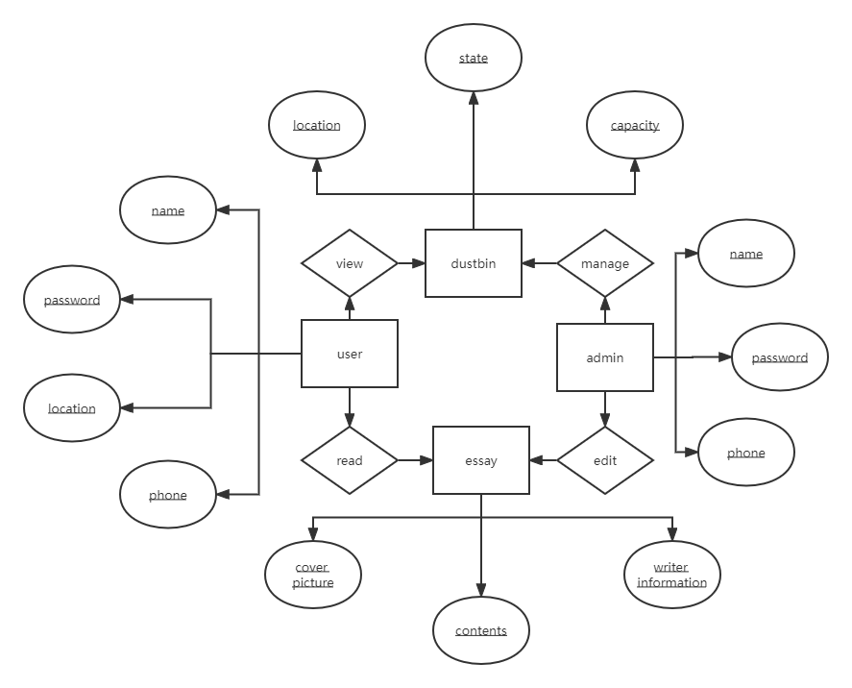

Fig. 7 Entity Relationship Diagram

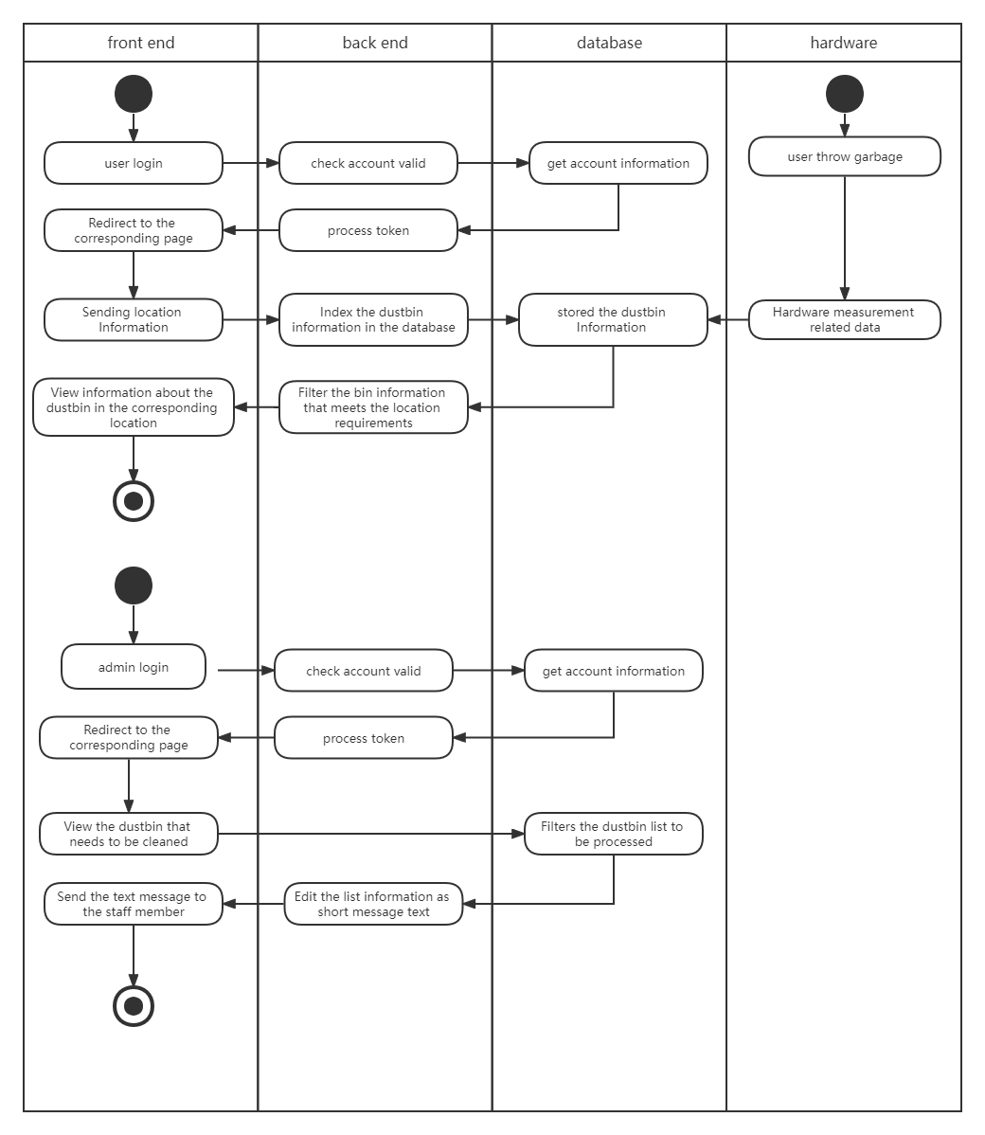

Fig. 8 Swim Lane Diagram

## 3.2.4 Visualization

Persons in charge: Zhijun Zhao, Yinheng Lin

Description: The visualization part is the presentation of the back-end part to users and administrators in the form of an easy-to-operate web page.

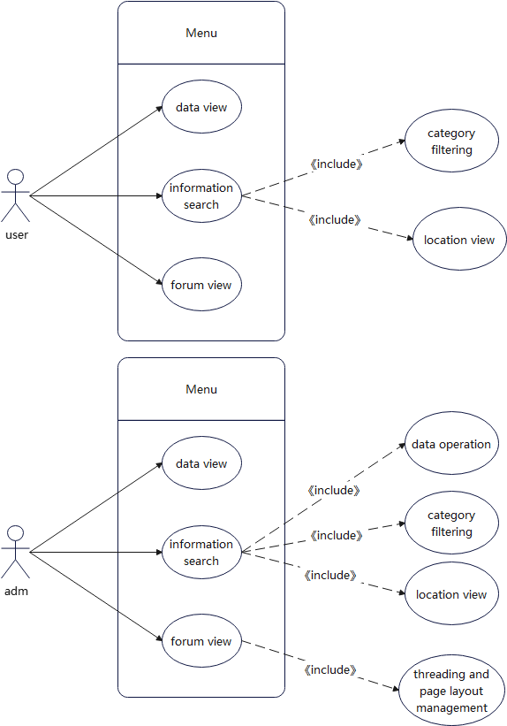

Fig. 9 Use Case Diagram

# **8. Interface Prototype**

## 8.1 Login screen

In the login screen, users can log in as a user or administrator using their account password. In addition, you can also register and retrieve your password from the login screen.

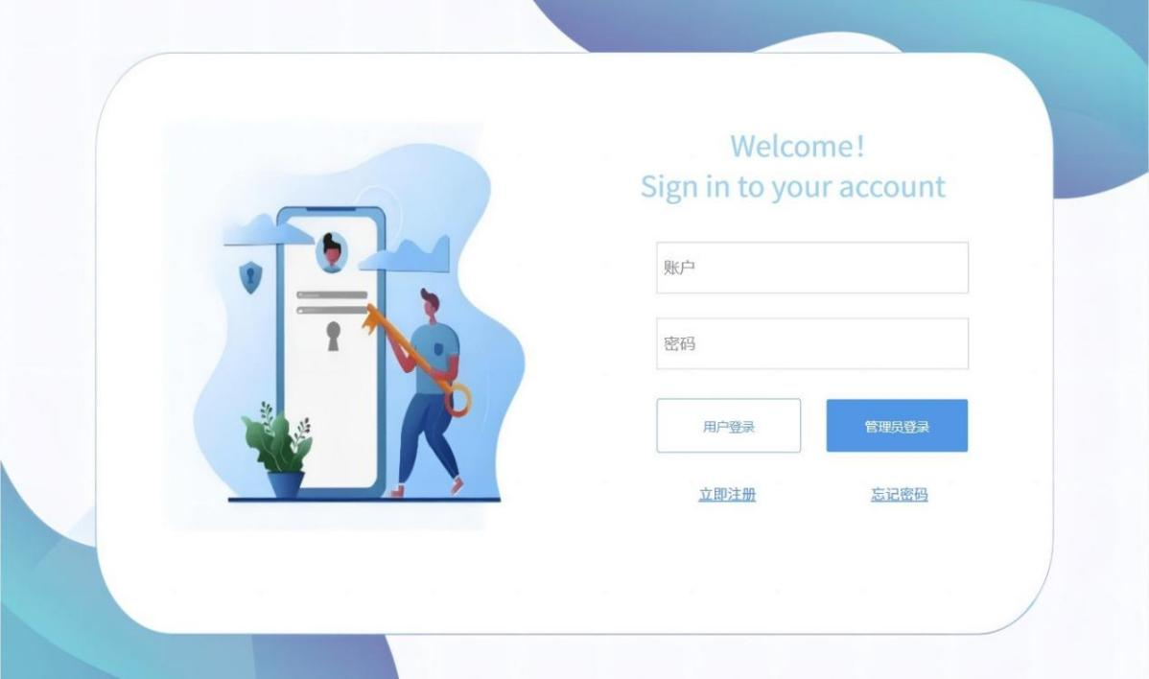

Fig. 10 Use Login page

## 8.2 User Interface

**8.2.1 Map Location**

With the satellite 3D map, users can easily and quickly select the specific floor they want to search from the map page.

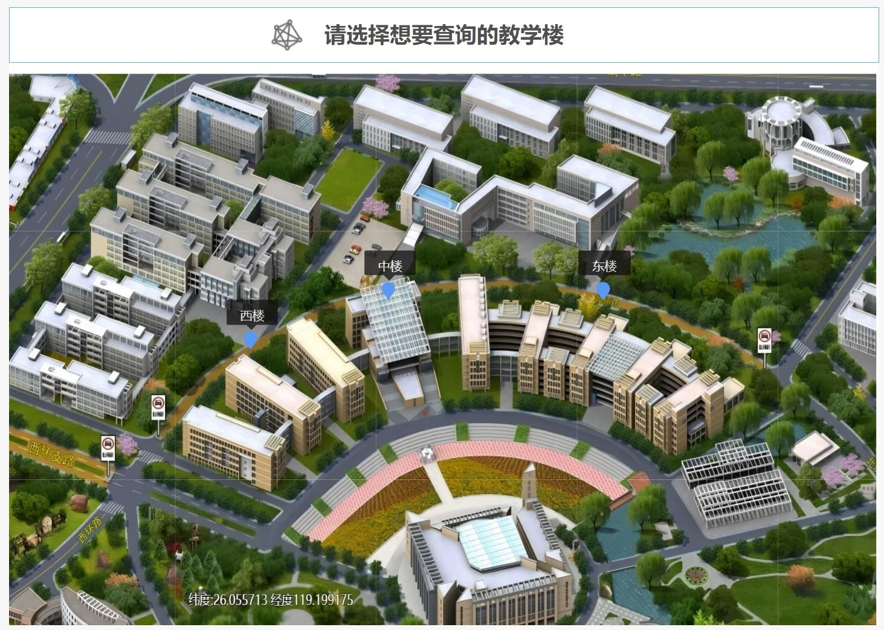

Fig. 11 Map page

**8.2.2 Data Visualization**

After selecting a specific building, the data visualization allows users to view the number and capacity of various types of garbage bins on that floor.

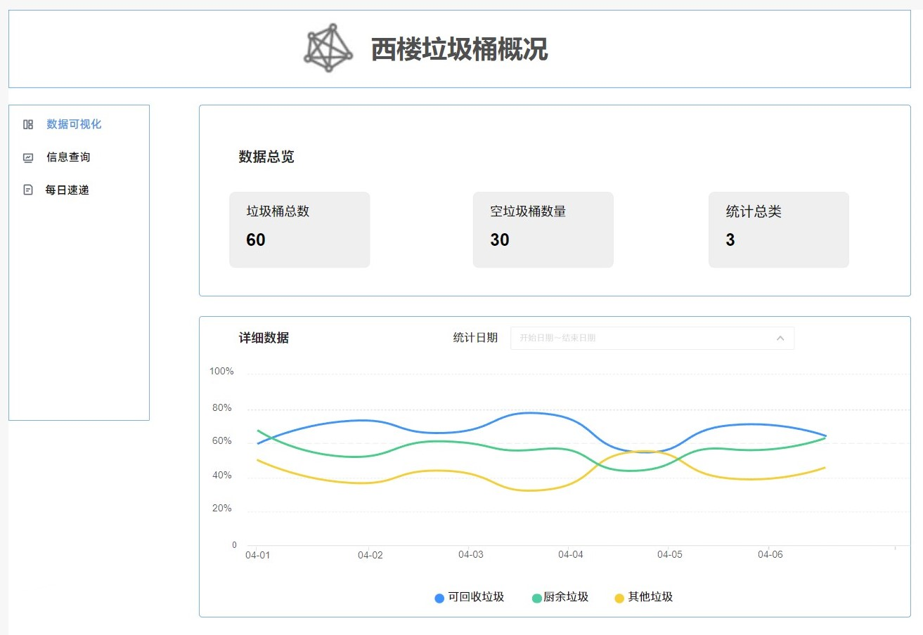

Fig. 12 Data Visualization page

**8.2.3 Information Search**

Users can also use the left menu bar to go to the information query interface, which allows users to search for garbage bins in three categories: garbage bins distribution, status and type, and to determine the location of them by "View Specific Location" to facilitate the search of target bins.

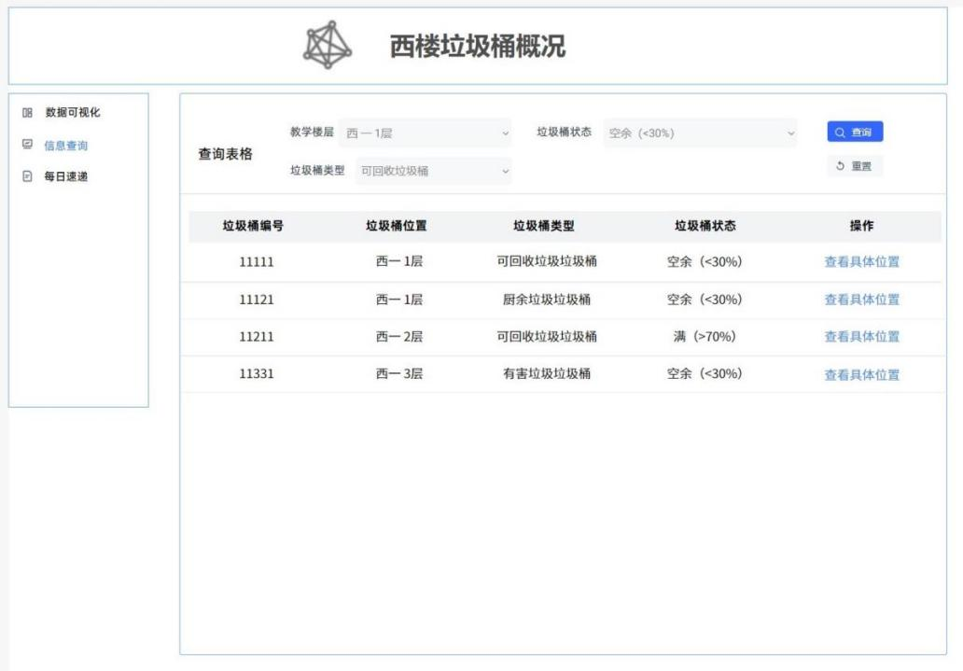

Fig. 13 Information Search page

**8.2.4 Daily Express**

After clicking the Daily Express, users can browse the articles related to garbage sorting on the website, which helps users learn about garbage sorting and also helps to promote garbage sorting.

Fig. 14 Daily Express page

## 8.3 Administrator Interface

**8.3.1 Map Location**

The map positioning is consistent with the user interface.



Fig. 15 Map Location page for Administrator

**8.3.2 Data Visualization**

The data visualization interface is consistent with the user interface.



Fig. 16 Data Visualization page

**8.3.3 Information Search**

Compared with the user's information inquiry page, the administrator page adds the function of deleting and modifying garbage bins.

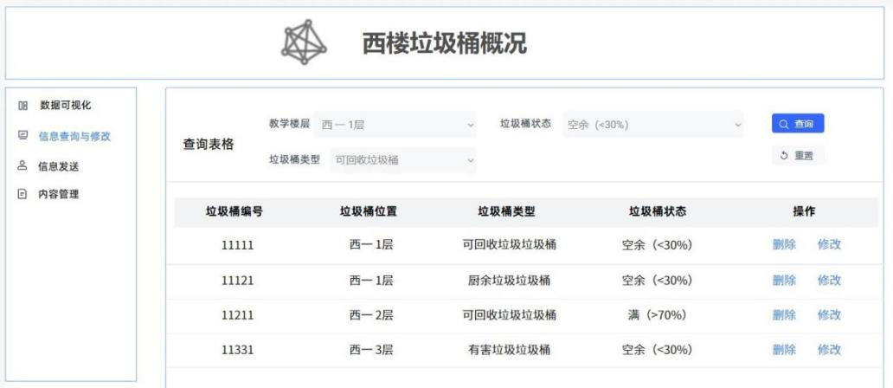

Fig. 17 Information Search page for supervisor

**8.3.4 Information Sending**

In addition, the administrator can send the edited garbage can information to the cleaning staff through the message sending page to remind the cleaning staff to clean the garbage bins in time.

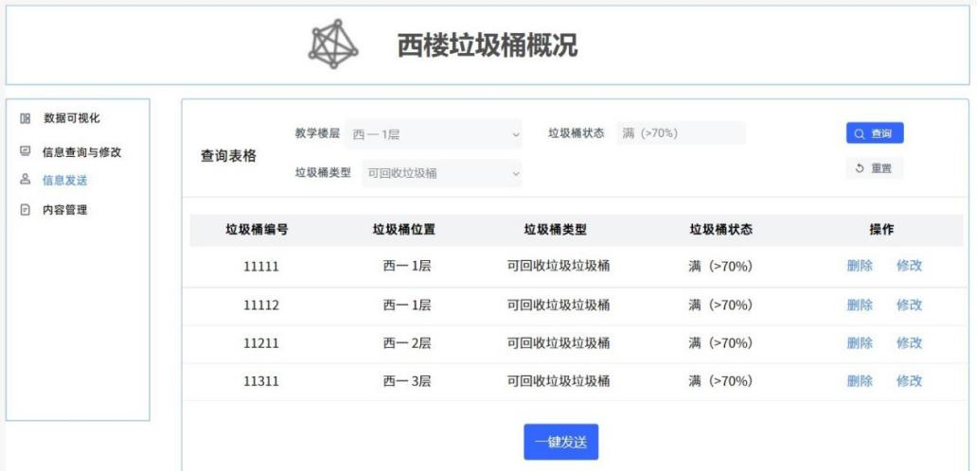

Fig. 18 Information Sending page

**8.3.5 Content Management**

Administrators can publish articles on the content management page and edit and delete articles that are pushed daily directly from this interface.

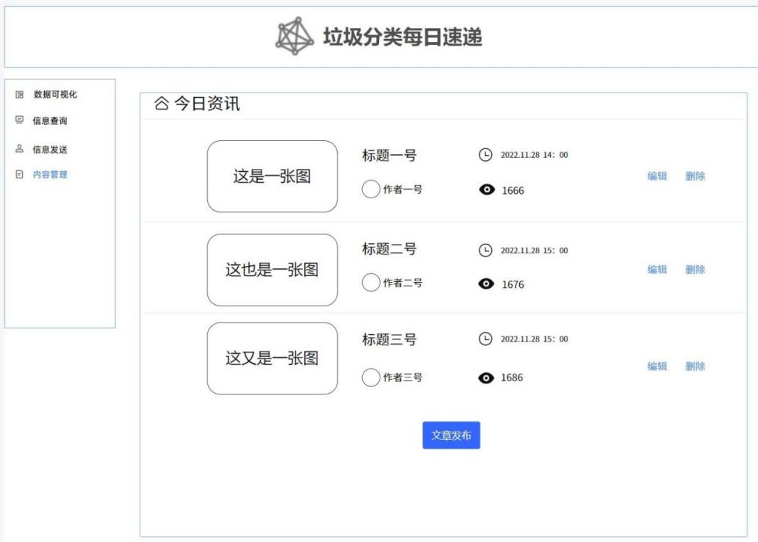

Fig. 19 Content Management page

# **9. Function Description**

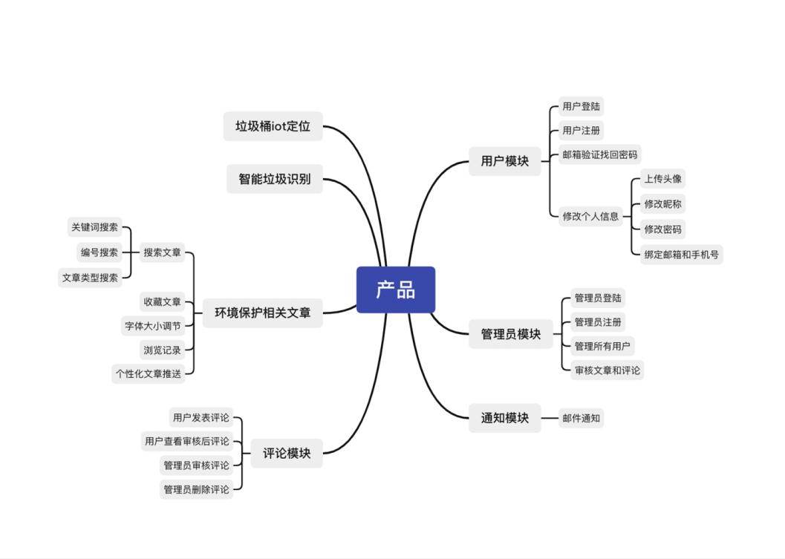

Fig. 20 Function Description

By using this software, users can not only do the simple use of garbage sorting function in daily life, but also browse environmental protection. It also allows you to view articles about environmental protection, national guidelines, real-time news, etc. Schools and families can also use this software to educate their children about environmental protection and waste separation.

## 9.1 User Module

**9.1.1 Basic Function**

Basic function: It provides the login registration function with mailbox as the main medium, so that users can get an independent id in the product and realize the record of relevant information that users need the product to record for them, so that it is convenient for users to use real-time synchronized data across devices.

**9.1.2 Password Retrieval Function**

Password retrieval function: Considering the habit of international groups of users using mailbox, this software provides the way of mailbox verification to retrieve the password, which is convenient for all kinds of user groups to use.

**9.1.3 Personalization Function**

Users can modify personal information such as avatar, nickname, password and change bound mailbox and cell phone number on this software, which provides users with better personalized customization service and facilitates the migration of user account information.

## 9.2 Administrator Module

**9.2.1 Basic Function**

Provide administrator login and registration service, facilitate to confirm and record the information of each administrator and improve system security.

**9.2.2 User Management Function**

User management function: The administrator can manage all users and effectively restrict some users from disturbing the harmonious environment or illegal operations.

**9.2.3 Audit Function**

The administrator is responsible for auditing the articles and comments issued by users, effectively avoiding the appearance of some articles and comments that are meaningless or not in harmony with the regulations, avoiding the destruction of the platform communication environment and spreading wrong information.

**9.2.4 Delete Function**

The administrator has the authority to delete bad comments to effectively curb the spread of bad comments and protect users' browsing experience.

## 9.3 Notification Module

**9.3.1 Email Notification**

Email notification is sent through the bound email number to keep users informed of important information and important status changes of the software.

**9.3.2 Other Ways**

Considering that some sanitation workers do not know how to use the equipment, we provide accurate and easy-to-read instructions for garbage disposal staff through BOT phone and cell phone SMS, and provide a variety of simple guidance ways, fully considering practical scenarios and humanistic care.

## 9.4 Garbage Management Module

**9.4.1 Garbage Bin Positioning Function**

It provides garbage bins IoT positioning function, which can realize the surrounding garbage bin positioning query for users and avoid unnecessary troubles such as spending time to find garbage bins.

**9.4.2 Intelligent Garbage Identification Function**

The software can obtain the garbage pile status of each garbage can, which is convenient for the garbage disposal staff to grasp the status information of each garbage can more clearly and improve the working efficiency. At the same time, it also provides the government and other garbage disposal system service providers with comprehensive and multi-dimensional garbage information and provides early warning alerts on garbage level according to certain algorithms and provides service providers with important solutions such as evaluation of garbage bin placement efficiency and placement strategy, and the best scheduling route for garbage trucks.

## 9.5 Environmental Protection Related Articles Module

**9.5.1 Search Function**

Provide multiple article search functions such as keyword, article type and number, so that users can get the information of the articles they need more quickly.

**9.5.2 Collection Function**

Provide article collection function, which is convenient for users to save the article path they want for a long time and open it at any time.

**9.5.3 Record Function**

Provide browsing record saving function, convenient for users to roll back the query and look back at the previously browsed articles.

**9.5.4 Customization Function**

The software is open to personalized settings for font size adjustment to ensure that users with different visual status and habits can get the most comfortable browsing visual experience.

**9.5.5 Push Function**

The software can collect users' browsing preferences based on their browsing information and provide users with personalized push function to improve the speed of information collection per unit of time, get better information acquisition experience and improve the promotion effect of environmental protection information.

## 9.6 Comment Module

**9.6.1 Comment Viewing System**

The comments displayed by the software are all comments reviewed by the administrator, filtering useless and bad comments to ensure a harmonious comment viewing experience for users and the platform comment environment.

**9.6.2 Publishing Function**

Provide article comment publishing function, so that users have the freedom to express their views and feelings of the channel, to provide a platform for users to discuss together, to improve the user participation experience.

# **10. Acceptance Verification Criteria**

## 10.1 Layout Test

**10.1.1 IoT Data Upload Test**

The bin information can be uploaded once every three seconds. The corresponding data information is read in the IoT platform.

**10.1.2 Back-end Data Acquisition and Processing**

The back-end can get the json data smoothly and parse it. The data is successfully processed using algorithms such as simulated annealing, and the shortest path is obtained.

**10.1.3 Front-end Data Display Test**

The front-end can accept the data sent by the back-end and display it beautifully.

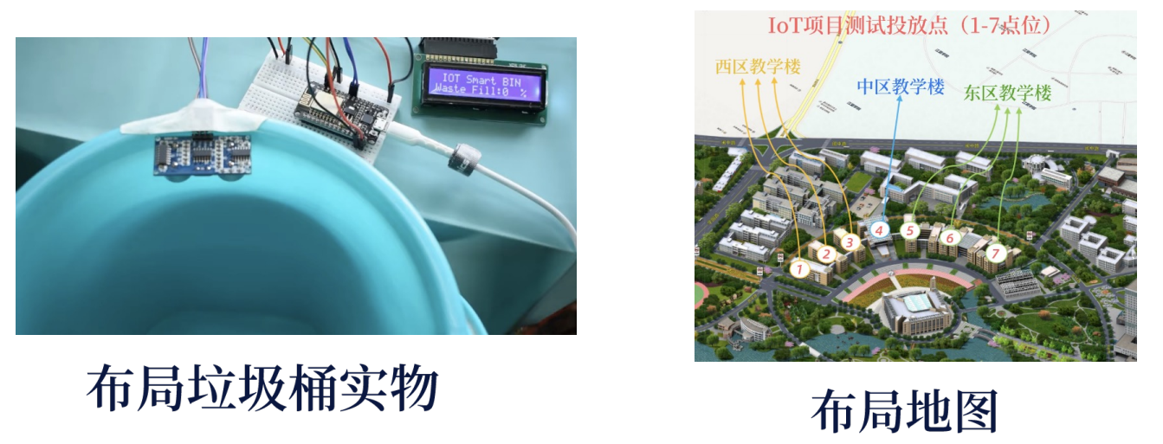

Fig. 21 Test figures

## 10.2 Data Visualization

**10.2.1 Device Display**

The device can be connected to Gaode Map SDK smoothly, and get the required area map, and successfully display the device location on the map.

**10.2.2 Data Visualization**

ThingBoard IoT platform can be used, and the corresponding data modules can be displayed for data visualization using the platform.

**10.2.3 Bin Status Display**

device display and data module can be combined with each other to display, i.e. click on the map to display the location of smart bins and bin status in the area.

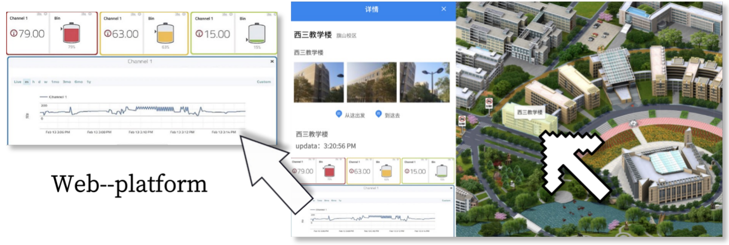

Fig. 22 Bin Status figures

## 10.3 User Interaction

**10.3.1 Email Sending**

When the software has important push information, it can smoothly send email information to all or specified user groups correctly.

**10.3.2 SMS and Telephone Voice Reminding**

When the software calculates the location that needs to be handled by the staff of body type garbage cleaning, it can send SMS and IOT telephone voice to the corresponding staff cell phone for reminding smoothly and accurately, and the content of SMS and voice is accurate.

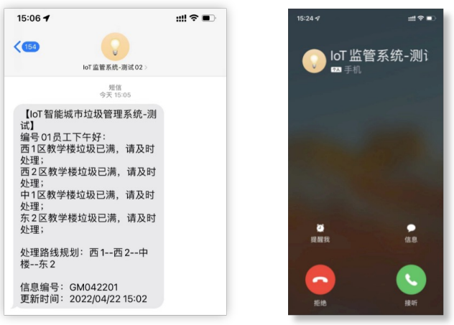

Fig. 23 SMS and Telephone Voice Reminding

# **11. Acknowledgements**

First and foremost, we gratefully acknowledge our lecturer **Mr. Lin** for his generous guidance and support during this work. And we would like to thank **Dr. Chin-Hong Wong** and **Dr. Zhicong Chen** for their constructive suggestions.

Also, none of this work would have been possible without the support of the Key Laboratory of Industrial Automation Control Technology and Information Processing, Fuzhou University, China.

**Lastly, thanks to our team members. We believe in, support and love each other.**

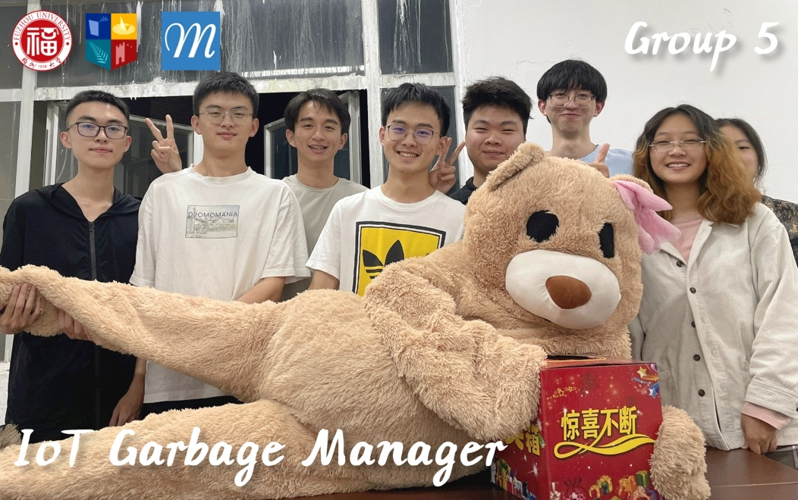

Fig. 24 Our Team Photo (1st Dec. 2022)